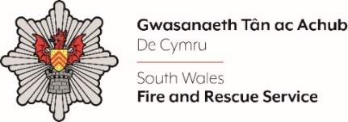
Shortlisting evidence Template – Group Manager B 2024

Dear Candidate,

Please complete the form below in FULL adhering to the 300-word limit for each of the shortlisting criteria (i.e. max of 1500 words). Then save in a Word document format and upload to the ‘supporting evidence’ section of the online application.

Please note that for shortlisting purposes we will be removing ‘Name’ and ‘National Insurance number’ and each candidate will be provided with a candidate number for anonymised shortlisting.

For any queries please contact personnel@southwales-fire.gov.uk

Full Name:
National Insurance Number:
Anonymised Candidate Number (to be completed by FRS HR team)
Shortlisting Criteria 1:
Please outline how you meet the eligibility criteria requirements for this role.
Shortlisting Criteria 2:
Please outline how you have role modelled and mentored others in how they communicate and engage to encourage inclusion.
Shortlisting Criteria 3:
Please outline how you have worked with people both inside and outside the organisation to set clear work and objectives whilst actively monitoring the performance of your teams and providing positive developmental feedback.
Shortlisting Criteria 4:
Please outline how you have monitored the quality of service delivery and how you shared information and metrics so that people know how well we are performing to make necessary changes.
Shortlisting Criteria 5:
Please outline how you have taken ownership of implementing and embedding change and how you help others to understand and adapt to change.
Closing date - 12:00pm midday on Monday 15th July 2024

