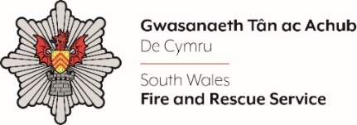
Shortlisting evidence Template – Station Manager A 2024

Dear Candidate,

Please complete the form below in FULL adhering to the 300-word limit for each of the shortlisting criteria (i.e. max of 1500 words). Then save in a Word document format and upload to the ‘supporting evidence’ section of the online application.

Please note that for shortlisting purposes we will be removing ‘Name’ and ‘National Insurance number’ and each candidate will be provided with a candidate number for anonymised shortlisting.

For any queries please contact personnel@southwales-fire.gov.uk

Full Name:
National Insurance Number:
Anonymised Candidate Number (to be completed by FRS HR team)
Shortlisting Criteria 1:
Please outline how you meet the eligibility criteria requirements for this role.
Shortlisting Criteria 2:
Please outline how you have created a culture where individual and team wellbeing is a priority and where you have systems in place to make sure teams you lead are coping.
Shortlisting Criteria 3:
Please outline how you value your team and how you make the best of their diverse skills and strengths.
Shortlisting Criteria 4:
Please outline how you have developed and implemented thoughtful solutions or recommendations based on sound evidence and feedback from internal and external sources.
Shortlisting Criteria 5:
Please outline how you encourage and respond to being challenged and how you show you are willing to adapt thinking with new information or better evidence.
Closing date - 12:00pm midday on Monday 15th July 2024

