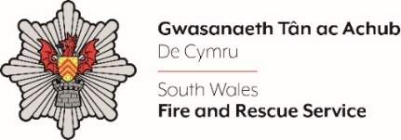
Shortlisting evidence Template – Administrative Assistant

Dear Candidate,

Please complete the form below in FULL adhering to the 300-word limit for each of the shortlisting criteria (i.e. max of 1500 words). Then save in a Word document format and upload to the ‘supporting evidence’ section of the online application.

Please note that for shortlisting purposes we will be removing ‘Name’ and ‘National Insurance number’ and each candidate will be provided with a candidate number for anonymised shortlisting.

For any queries please contact personnel@southwales-fire.gov.uk

Full Name:
National Insurance Number:
Anonymised Candidate Number (to be completed by FRS HR team)
I am looking for (please tick all that apply):
Full Time |  | Part Time |  |  | Permanent |  | Fixed Term
Shortlisting Criteria 1:
Please outline how you meet the following experience and qualification criteria for this role i.e.
  - Minimum GCSE Grade C or above in English Language and Mathematics OR equivalent qualifications (e.g. Essential/Key Skills Level 2).
  - Proven experience of using Microsoft Office Packages, including Word, Excel and Outlook.
  - Experience of working in an administrative role.
Shortlisting Criteria 2:
Please outline how you look for opportunities to learn and develop your skills and behaviours
Shortlisting Criteria 3:
Please outline how you value and appreciate differences in people and treat everyone with kindness and respect
Shortlisting Criteria 4:
Please outline how you plan and prioritise your work, managing time effectively to get things done within set timescales
Shortlisting Criteria 5:
Please outline how you are open to and positively engage with new ways of working
Closing date - 12:00pm midday on Monday 16th December 2024

