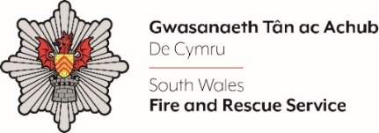
CHIEF OF STAFF
Shortlisting Evidence

Please complete the form below in FULL adhering to the 500-word limit for each of the shortlisting criteria (i.e. max of 2000 words). Then save in a Word document format and upload to the ‘supporting evidence’ section of the online application.

Please note that for shortlisting purposes we will be removing ‘Name’ and ‘National Insurance number’ and each candidate will be provided with a candidate number for anonymised shortlisting.

For any queries please contact recruitment@southwales-fire.gov.uk or for internal queries, please contact us via 24/7

Full Name:
National Insurance Number:
Anonymised Candidate Number (to be completed by FRS HR team)
QUESTIONS
Shortlisting Criteria 1: ELIGIBILITY: Reviewing the essential criteria stated in the person specification above, please outline what skills and experiences you have that make you the right person for this role
Shortlisting Criteria 2: ORGANISATIONAL EFFECTIVENESS: Please provide evidence of your ability to work collaboratively, effectively and efficiently with multiple stakeholders (internal and external)
Shortlisting Criteria 3: PERSONAL IMPACT: Please describe how you are forward-thinking and able to troubleshoot independently with lots of initiative, energy and personal motivation
Shortlisting Criteria 4: RESILIENCE: Please provide evidence that demonstrates how you have delivered high performance in a fast-paced environment whilst maintaining resilience and personal wellbeing
Closing date – 18th February 2025, 12:00 midday

