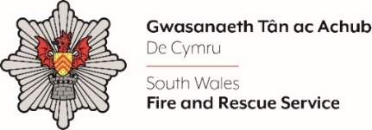
Motor Vehicle Technician

Shortlisting evidence Template

Please complete the form below in FULL adhering to the 350-word limit for each of the shortlisting criteria (i.e. max of 1750 words). Then save in a Word document format and upload to the ‘supporting evidence’ section of the online application.

Please note that for shortlisting purposes we will be removing ‘Name’ and ‘National Insurance number’ and each candidate will be provided with a candidate number for anonymised shortlisting.

For any queries please contact recruitment@southwales-fire.gov.uk or for internal queries, please contact us via 24/7.

Full Name:
National Insurance Number:
Anonymised Candidate Number (to be completed by FRS HR team)
Shortlisting Criteria 1:

Please demonstrate how you meet the eligibility criteria as stated within the Person Specification.

Shortlisting Criteria 2:

Please evidence your knowledge of auto electrical systems.

Shortlisting Criteria 3:

Please outline your comprehensive knowledge and experience in the repair and maintenance of LGV Category C or PCV category vehicles.

Shortlisting Criteria 4:

Tell us about your experience of working on a wide range of major chassis Marques and vehicular systems.
Shortlisting Criteria 5:

Please describe your ability to embrace and value diversity and demonstrate a fair and ethical approach in all situations.
Closing date – 14.03.2025

