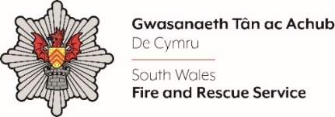
MULTIMEDIA DEVELOPER

Shortlisting evidence Template

Please complete the form below in FULL adhering to the 500-word limit for each of the shortlisting criteria (i.e. max of 2500 words). Then save in a Word document format and upload to the ‘supporting evidence’ section of the online application.

Please note that for shortlisting purposes we will be removing ‘Name’ and ‘National Insurance number’ and each candidate will be provided with a candidate number for anonymised shortlisting.

For any queries please contact recruitment@southwales-fire.gov.uk or for internal queries, please contact us via 24/7

Full Name:
National Insurance Number:
Anonymised Candidate Number (to be completed by FRS HR team)
Shortlisting Criteria 1: Please provide your previous experience of providing multimedia solutions.

Shortlisting Criteria 2: Tell us your experience of working with Adobe Creative Suite (including Photoshop and Premier Pro).

Shortlisting Criteria 3: Please outline your ability to maintain a confident and resilient attitude in highly challenging situations.

Shortlisting Criteria 4: Please evidence your experience in proactively supporting change, and the ability to adjust approach to meet changing requirements.

Shortlisting Criteria 5: Demonstrate your commitment and ability to develop self, individuals, teams and others, to improve organisational effectiveness.

Closing date – 28th February 2025

