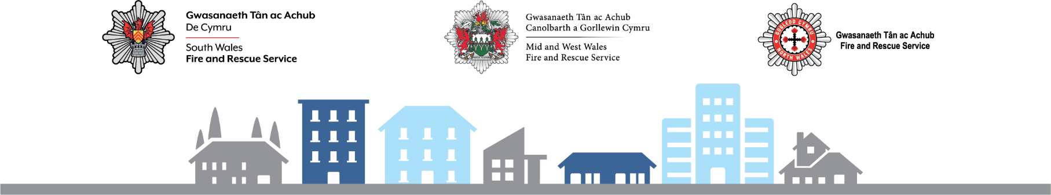

Fire Risk Assessment
1 | Premises particulars
Premises name
Address
Use of premises
Employer/Owner/Person(s) in control of the workplace
Date of assessment |  |  |  | Date(s) reviewed
 |  |  |  | Date of next review
Name and relevant details including relevant qualifications, training and experience in fire safety of the person undertaking the Fire Risk Assessment/review
Signed |  |  |  |  |  | Date

2 | General statement of policy
Statement

3 | General description of premises
Description
Occupancy
Times the premises are in use |  | From |  |  |  | To
The total number of persons employed within the premises at any one time
The total number of persons who may be present (including visitors) at the premises at any one time
Size
Building footprint (metres x metres) |  |  |  |  | Number of floors
Number of stairs
4 | Plan Drawing

5 | Identify fire hazards
Ignition sources
Fuel sources
Work processes
Structural features that could promote the spread of fire

6 | Identify people at risk
Identify people at risk in the event of a fire and their location within the premises. Outline why they are at risk, and what control measures are (or need to be) in place
Commentary

7 | Means of escape – horizontal evacuation
Commentary

8 | Means of escape – vertical evacuation
Commentary

9 | Fire safety signs and notices
Commentary

10 | Fire detection and warning
Commentary

11 | Emergency lighting
Commentary

12 | Fire fighting equipment
Commentary

13 | Other safety systems (e.g. sprinklers, automatic smoke extraction)
Commentary

14 | Maintenance
Is there a maintenance program for the fire safety provisions in the premises? Y/N
Commentary
Are regular checks of fire resisting doors, walls and partitions conducted? Y/N
Commentary
Are regular checks of escape routes and exit doors carried out? Y/N
Commentary
Are regular checks of fire safety signs carried out? Y/ N
Weekly
Six-monthly
Annually
Commentary
Is there a maintenance programme for the fire warning system? Y/ N
Commentary
Is there a maintenance programme for the emergency lighting? Y/ N
Monthly
Annually
Commentary
Is there maintenance of the fire fighting equipment (by competent person?) Y/ N
Weekly
Annually
Commentary
Is there a maintenance programme for other fire safety systems? Y/N
Commentary
Are records kept and their location identified? Y/N
Commentary

15 | Method for calling the Fire Service
Commentary

16 | Fire emergency plan (FEP)
Commentary

17 | Training
Commentary

18 | Significant findings
a) | Existing control measures
Significant findings |  | Control measures
b) | Fire safety deficiencies to be rectified
Deficiency/ Action/ Allocated to |  | Priority | Target date | Date rectified

