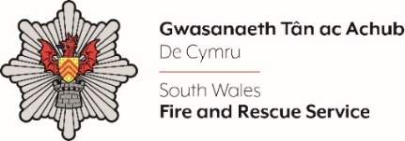
Watch Manager (B)

Shortlisting evidence Template

Please complete the form below in FULL adhering to the 500-word limit for each of the shortlisting criteria (i.e. max of 2000 words). Then save in a Word document format and upload to the ‘supporting evidence’ section of the online application.

Please note that for shortlisting purposes we will be removing ‘Name’ and ‘National Insurance number’ and each candidate will be provided with a candidate number for anonymised shortlisting.

For any queries please contact recruitment@southwales-fire.gov.uk or for internal queries, please contact us via 24/7

Full Name:
National Insurance Number:
Anonymised Candidate Number (to be completed by FRS HR team)
Shortlisting Criteria 1: Please provide an example of when you have been proactive in
contributing to change.
Shortlisting Criteria 2: Please detail your experience of operational incident management.

Shortlisting Criteria 3: Please demonstrate how you have been responsible for inclusion
and encouraging different points of view.

Shortlisting Criteria 4: Please provide an example of when you have personally supported and coached someone to aid their development.

Closing date – Midday 31st March 2025

