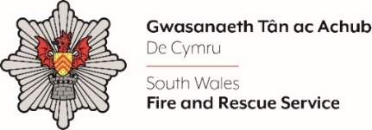
Legal Services Manager

Shortlisting evidence Template

Please complete the form below in FULL adhering to the 500-word limit for each of the shortlisting criteria (i.e. max of 1500 words). Then save in a Word document format and upload to the ‘supporting evidence’ section of the online application.

Please note that for shortlisting purposes we will be removing ‘Name’ and ‘National Insurance number’ and each candidate will be provided with a candidate number for anonymised shortlisting.

For any queries please contact recruitment@southwales-fire.gov.uk or for internal queries, please contact us via 24/7

Full Name:
National Insurance Number:
Anonymised Candidate Number (to be completed by FRS HR team)
Shortlisting Criteria 1: Please advise if you have a Law Degree or equivalent experience and whether you are a Solicitor, Barrister, fellow of the Institute of Legal Executives, or other comparable profession
Shortlisting Criteria 2: Please provide evidence that shows your experience in dealing with general legal matters across different legal areas
Shortlisting Criteria 3: Please describe your experience in at least one of the following areas of law: 1. Property 2. Contract or 3. GDPR & Information Management
Shortlisting Criteria 4: Please outline a time that you have had to work in full compliance with policy, legislative provisions and other guidance, respecting any sensitive information that is presented
Shortlisting Criteria 5: Please provide an example of your ability to promote and manage diversity and demonstrate a fair and ethical approach in all situations
Closing date – 8th April 2025 at 12:00 Midday

