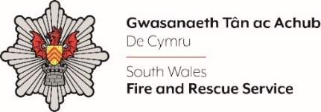
Transformation Programme Manager

Shortlisting evidence Template

Please complete the form below in FULL adhering to the 500-word limit for each of the shortlisting criteria (i.e. max of 1000 words). Then save in a Word document format and upload to the ‘supporting evidence’ section of the online application.

Please note that for shortlisting purposes we will be removing ‘Name’ and ‘National Insurance number’ and each candidate will be provided with a candidate number for anonymised shortlisting.

For any queries please contact recruitment@southwales-fire.gov.uk or for internal queries, please contact us via 24/7

Full Name:
National Insurance Number:
Anonymised Candidate Number (to be completed by FRS HR team)
Shortlisting Criteria 1:
Please submit a CV (No more than three pages) outlining your relevant knowledge and experience against the ‘Essential Criteria’ on the ‘Personal Specification’ page

Please submit as a document upload along with this shortlisting template

Shortlisting Criteria 2:
Please explain why you are interested in this role and highlight the skills and experiences that make you the ideal candidate to lead and motivate staff.

Shortlisting Criteria 3:
Please provide a statement outlining how your skills, experience, behaviours, and values align with the NFCC Core Code of Ethics.

Closing date – 18/04/2025

