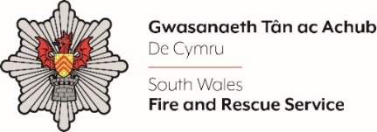
Independent Advisory Group

Shortlisting evidence Template

Please complete the form below in FULL adhering to the 500-word limit for each of the shortlisting criteria (i.e. max of 1500 words). Then save in a Word document format and upload to the ‘supporting evidence’ section of the online application.

Please note that for shortlisting purposes we will be removing ‘Name’ and ‘National Insurance number’ and each candidate will be provided with a candidate number for anonymised shortlisting.

For any queries please contact recruitment@southwales-fire.gov.uk or for internal queries, please contact us via 24/7

Full Name:
National Insurance Number:
Anonymised Candidate Number (to be completed by FRS HR team)
Question 1: Please explain why you are interested in becoming an IAG member: (Please use no more the 1000 words)

Question 2: Using the Role Profile and Person Specification please tell us what skills, experience and qualities you feel you would bring to the IAG: (Please use no more than 1000 words)
Closing date – 05/05/2025 at Midday

