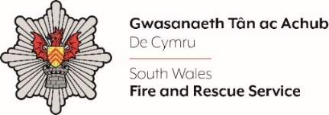
Procurement Officer

Shortlisting evidence Template

Please complete the form below in FULL adhering to the 500-word limit for each of the shortlisting criteria (i.e. max of 3000 words). Then save in a Word document format and upload to the ‘supporting evidence’ section of the online application.

Please note that for shortlisting purposes we will be removing ‘Name’ and ‘National Insurance number’ and each candidate will be provided with a candidate number for anonymised shortlisting.

For any queries please contact recruitment@southwales-fire.gov.uk or for internal queries, please contact us via 24/7

Full Name:
National Insurance Number:
Anonymised Candidate Number (to be completed by FRS HR team)
Question 1: CIPS Level 6 membership or equivalent

Question 2: Experience in high value procurement exercises and wider activities, working on own initiative and as part of a wider project team in the Public Sector

Question 3: Ability to work in full compliance with organisational policy and legislative guidance, respecting sensitive information presented

Question 4: Ability to lead, involve and motivate others both internal to the Fire & Rescue Service and external partners.

Question 5: Ability to communicate effectively both orally and in writing to a wide range of audiences

Question 6: Ability to understand and apply relevant information to make appropriate decisions which reflect key priorities and requirements.

Closing date – 01/05/2025 at 12pm

