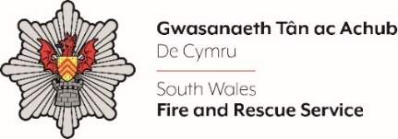
Business Fire Safety Support Officer

Shortlisting evidence Template

Please complete the form below in FULL adhering to the 500-word limit for each of the shortlisting criteria (i.e. max of 2500 words). Then save in a Word document format and upload to the ‘supporting evidence’ section of the online application.

Please note that for shortlisting purposes we will be removing ‘Name’ and ‘National Insurance number’ and each candidate will be provided with a candidate number for anonymised shortlisting.

For any queries please contact recruitment@southwales-fire.gov.uk or for internal queries, please contact us via 24/7

Full Name:
National Insurance Number:
Anonymised Candidate Number (to be completed by FRS HR team)
Shortlisting Criteria 1:

What is your knowledge of Fire Safety Legislation and associated work
Shortlisting Criteria 2:

Detail your experience of Microsoft Office Packages e.g Outlook, Word, Excel, Office 365
Shortlisting Criteria 3:

Please outline your experience of working in an administrative role
Shortlisting Criteria 4:

Provide an example of how you are proactive in supporting change and the ability to meet changing requirements
Shortlisting Criteria 5:

Ability to understand and apply relevant information to make appropriate decisions and create practical solutions.
Closing date – 18/04/2025 at 12pm

